Московский авиационный институт (национальный исследовательский университет)

Институт № 8 «Информационные технологии и прикладная математика»

**Лабораторная работа №2**

**по курсу «Теоретическая механика»**

**Анимация системы**

Выполнил студент группы М8О-201Б-21 Старцев Иван Романович

Преподаватель: Чекина Евгения Алексеевна

Оценка:

Дата: 03.11.2022

Москва, 2022

**Вариант №40**

**Задание:**

# Реализовать анимацию движения системы, отобразить с помощью графиков абсолютную скорость и абсолютное ускорение.

**Механическая система:**

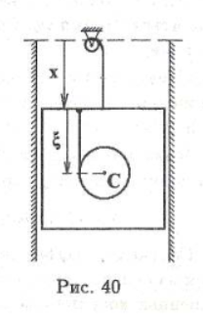

**Текст программы**

import numpy as np  
import matplotlib.pyplot as plt  
from matplotlib.animation import FuncAnimation  
import sympy as sp  
import math  
  
def Square(x0, y0):  
 PX = [x0 - 7.5, x0 - 7.5, x0 + 7.5, x0 + 7.5, x0 - 7.5]  
 PY = [y0 - 7.5, y0 + 7.5, y0 + 7.5, y0 - 7.5, y0 - 7.5]  
 return PX, PY  
  
def Circle(X, Y, R):  
 CX = [X + R * math.cos(i/100) for i in range(0, 628)]  
 CY = [Y + R * math.sin(i/100) for i in range(0, 628)]  
 return CX, CY  
  
# [Xнач, Xкон], [Yнач, Yкон] => для линии надо сделать конечным фиксированную точку, а начало привязать к вершине блока  
def anima(i):  
 PrX, PrY = Square(XR[i], YR[i])  
 Prism.set_data(PrX, PrY)  
 Line_upper.set_data([XR[i] + 0.2, 1], [YR[i] + 7.5, 23.15])  
 CX, CY = Circle(XC[i] + 0.3, 1.6 * YC[i] - 4, 3)  
 Circle_B.set_data(CX, CY)  
 CBX, CBY = Circle(XC[i] - 2.7, YR[i] + 7.3, 0.05)  
 Circle_BD.set_data(CBX, CBY)  
 Line_bottom.set_data([XC[i] - 2.7, XC[i] - 2.7], [1.6 * YC[i] - 4, YR[i] + 7.5])  
 BCX, BCY = Circle(XC[i] + 0.2, 1.6 * YC[i] - 4, 0.05)  
 Circle_BС.set_data(BCX, BCY)  
 return Prism, Line_upper, Circle_B, Circle_BD, Line_bottom, Circle_BС  
  
t = sp.Symbol('t')  
x = 4 * sp.cos(3 * t)  
xi = -1.5 * sp.cos(3 * t)  
  
Xr = x * sp.sin(math.pi) + 0.8  
Yr = -x * sp.cos(math.pi) + 7.5  
  
print(Xr)  
  
Xc = 1.5 * (x * sp.sin(math.pi) + 0.8)  
Yc = 2.5 * (xi * sp.cos(math.pi) + 3)  
  
V_X = sp.diff(x, t)  
Vx = V_X * sp.cos(math.pi)  
Vy = -V_X * sp.sin(math.pi)  
  
Wx = sp.diff(Vx, t)  
Wy = sp.diff(Vy, t)  
  
# для графиков  
V_Xi = sp.diff(xi, t)  
V_X_Xi = V_X + V_Xi  
W_X_Xi = sp.diff(V_X_Xi, t)  
  
T = np.linspace(0, 20, 1000)  
XR = np.zeros_like(T)  
YR = np.zeros_like(T)  
XC = np.zeros_like(T)  
YC = np.zeros_like(T)  
WX = np.zeros_like(T)  
WY = np.zeros_like(T)  
YX = np.zeros_like(T)  
YC = np.zeros_like(T)  
VX = np.zeros_like(T)  
VY = np.zeros_like(T)  
  
for i in np.arange(len(T)):  
 XR[i] = sp.Subs(Xr, t, T[i])  
 YR[i] = sp.Subs(Yr, t, T[i])  
 XC[i] = sp.Subs(Xc, t, T[i])  
 YC[i] = sp.Subs(Yc , t, T[i])  
 VX[i] = sp.Subs(Vx, t, T[i])  
 VY[i] = sp.Subs(Vy, t, T[i])  
 WX[i] = sp.Subs(Wx, t, T[i])  
 WY[i] = sp.Subs(Wy, t, T[i])  
  
fig = plt.figure(figsize = (17, 10))  
  
ax1 = fig.add_subplot(121)  
ax1.axis('equal')  
ax1.set(xlim=[XR.min() - 20, XR.max() + 20], ylim=[YR.min() - 20, YR.max() + 20])  
  
A_R = 1  
A_X = 0  
A_Y = 22.9  
Circle_A = ax1.plot(*Circle(A_X, A_Y, A_R), 'black', linewidth=2)  
  
AD_R = 0.1  
AD_X = 0  
AD_Y = 22.9  
Circle_AD = ax1.plot(*Circle(AD_X, AD_Y, AD_R), 'black', linewidth=3)  
  
B_R = 3  
B_X = 0  
B_Y = 10  
Circle_B = ax1.plot(*Circle(B_X, B_Y, B_R), 'black', linewidth=2)[0]  
  
BD_R = 0.05  
BD_X = -2.5  
BD_Y = 18.9  
Circle_BD = ax1.plot(*Circle(BD_X, BD_Y, BD_R), 'black', linewidth=3)[0]  
  
BС_R = 0.05  
BС_X = XR[0] + 0.2  
BС_Y = YR[0] + 1.8  
Circle_BС = ax1.plot(*Circle(BС_X, BС_Y, BС_R), 'black', linewidth=3)[0]  
  
upper_line_x = [-12, 14]  
upper_line_y = [24, 24]  
plt.plot(upper_line_x, upper_line_y, 'black')  
side_line1_x = [-7.5, -7.5]  
side_line1_y = [-10, 24]  
plt.plot(side_line1_x, side_line1_y, 'black')  
side_line2_x = [9, 9]  
side_line2_y = [-10, 24]  
plt.plot(side_line2_x, side_line2_y, 'black')  
  
PrX, PrY = Square(XR[0], YR[0])  
Prism = ax1.plot(PrX, PrY, 'black')[0]  
  
Line_upper = ax1.plot([1, 1], [22.5, 19], 'black')[0]  
Line_bottom = ax1.plot([-1.9, -1.9], [11, 18.8], 'black')[0]  
  
  
# ГРАФИКИ  
T = np.linspace(0, 20, 1000)  
VP = np.zeros_like(T)  
WP = np.zeros_like(T)  
l = np.zeros_like(T)  
  
for i in np.arange(len(T)):  
 VP[i] = sp.Subs(V_X_Xi, t, T[i])  
 WP[i] = sp.Subs(W_X_Xi, t, T[i])  
 l[i] = i  
  
ax2 = fig.add_subplot(424)  
ax2.plot(l, VP)  
ax2.set_ylabel('V of point')  
  
ax4 = fig.add_subplot(426)  
ax4.plot(l, WP)  
ax4.set_ylabel('W of point')  
  
plt.subplots_adjust(wspace = 0.3, hspace = 0.7)  
  
anim = FuncAnimation(fig, anima, frames = 1000, interval = 0.01, blit = True)  
  
plt.show()

**Результат работы программы:**

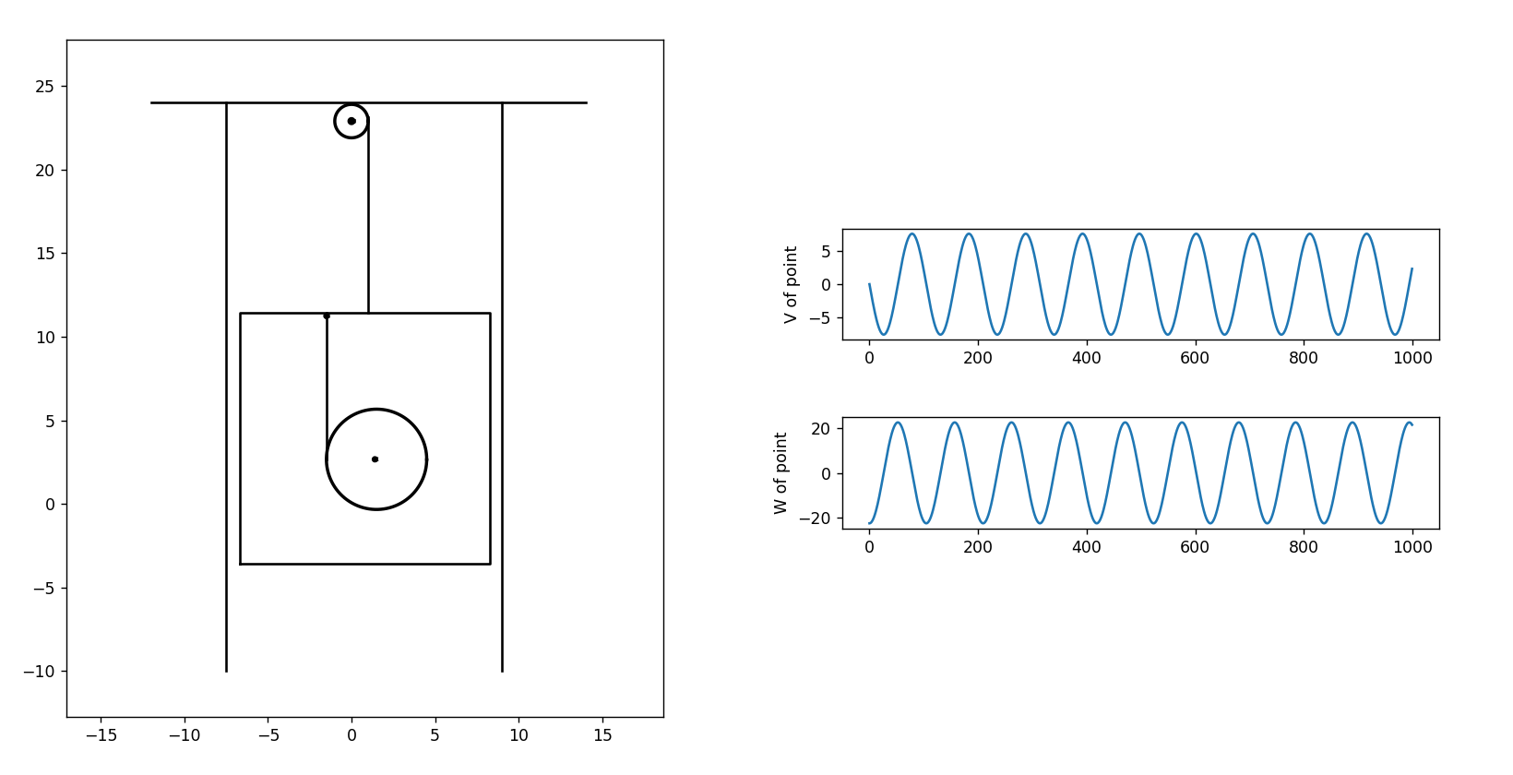

**Вывод:**

В ходе выполнения данной лабораторной работы были получены навыки анимации системы на языке Python.